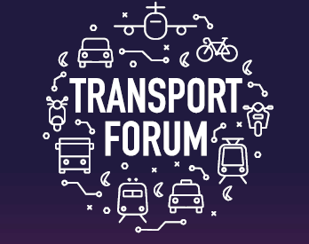 **Manchester Airport Transport Forum 2019**

**Speaker Biographies:**

**Tim Wood, *Northern Powerhouse***

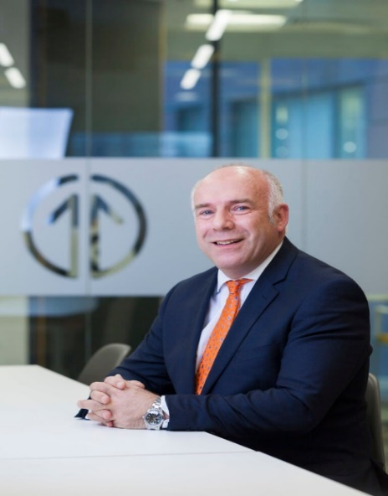

**Tim Wood** has over 22 years’ experience in railway design and delivery and prior to this, 11 years spent in the construction industry.

As Northern Powerhouse Rail Director, he took on the challenge to make the strategic outline business case (SOBC) for investment in an ambitious plan for a transformed rail network that will provide fast, frequent and reliable links between the North’s six biggest city regions and its largest airport. He has led on the delivery of the SOBC and works around the HS2 touch points in a co-clienting role with the Department for Transport.

Previously he held two Rail Director positions in the private sector and is known for early development of Rail PPP schemes and partner and stakeholder management.

**David Sidebottom, *Transport Focus***

**David Sidebottom** started his role as Transport Focus’s Director in June 2011. He initially started working at Transport Focus in January 2006 as a Passenger Link Manager before being promoted to the post of Bus Passenger Director in January 2010. David was responsible for the planning and delivery of Transport Focus’s new bus, coach and tram passenger representation duties. Prior to this, he spent over 11 years representing the needs and interests of energy consumers in the north west of England where he was regional director of energywatch, the gas and electricity consumer council.

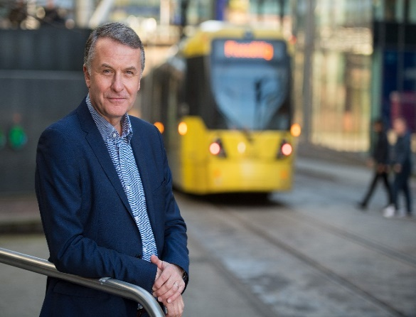



**John Boughton*, National Express***



John has been Commercial Director of National Express since 2017, with responsibility for all revenues, commercial and partnership activity for the UK's national coach network. Prior to National Express, John worked in other areas of the travel industry for almost 15 years, spending much of that time as a director of travel giant TUI, with roles at Thomson, First Choice and Exodus, amongst others.

**Danny Elford, *Stagecoach***

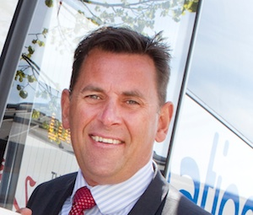

With a background as a Mechanical Engineer, Danny has spent over 35 years in the passenger transport sector, working closely with bus and coach transport provisions he has also spent 10 years working within Department for Transport as a Senior Policy advisor on UK and European legislation. Danny has operated at board level since 2010 and joined Stagecoach in September 2018.

Danny’s portfolio includes the 18 operational companies within the Stagecoach business, identifying new and developing existing opportunities to deliver growth.

Danny is also the Stakeholder Relationship Director at many UK Airports including the Manchester Airport Group.